LAB 1: INPUT THROUGH SCANNER CLASS AND COMMAND LINE ARGUMENT

Name: Shreyas Sawant Div: D7A Roll No.: 55

Q1 Write a program to check whether the number taken from user is Armstrong or not.

a)With CLA

CODE:

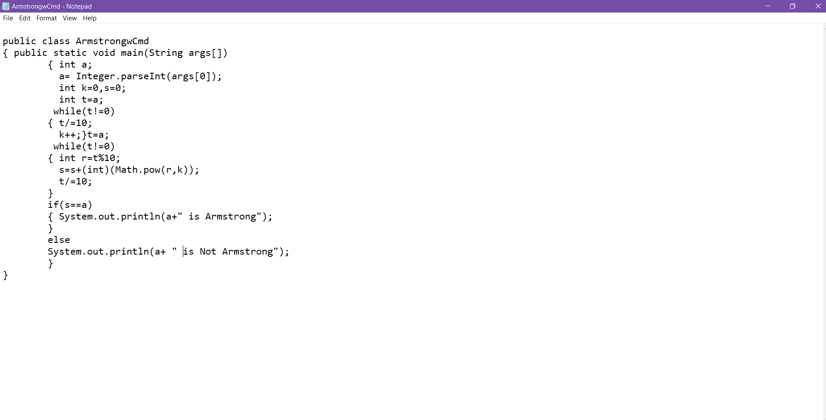

OUTPUT

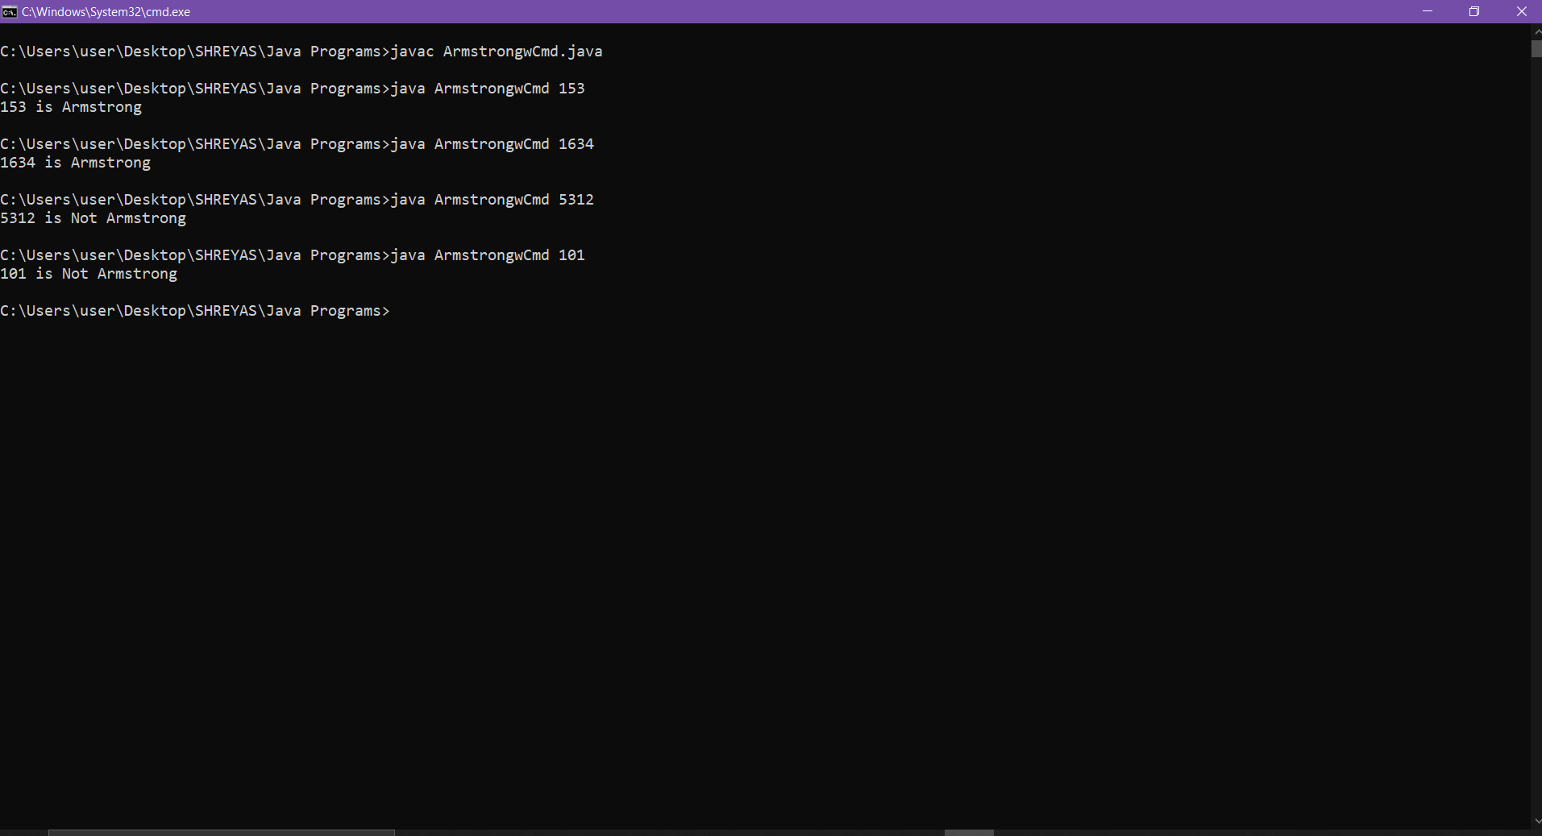

b) With Scanner Class

CODE:

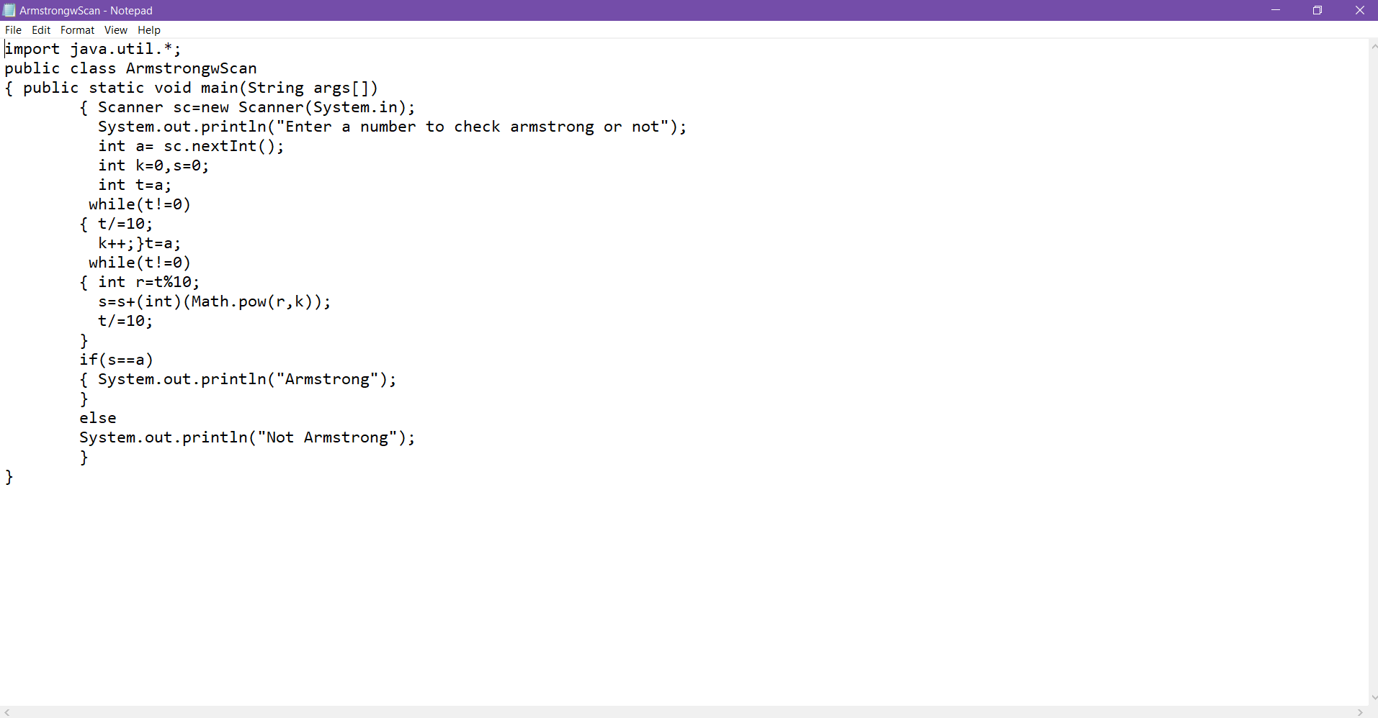

OUTPUT:

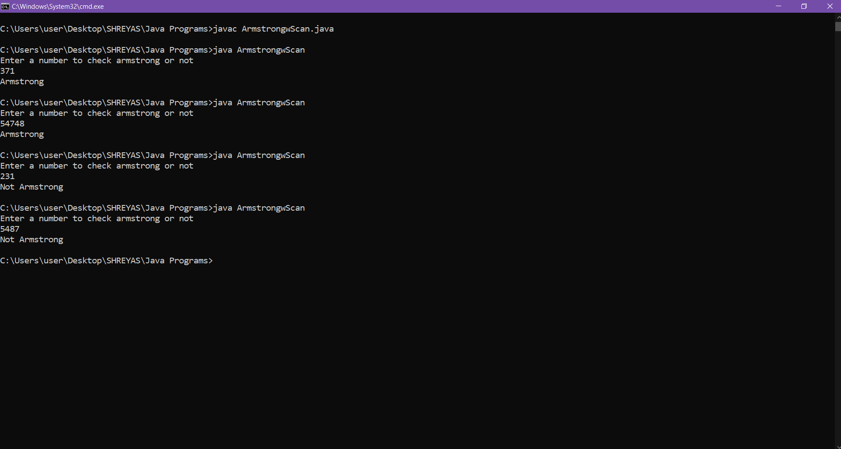

Q.2 Write a program to print factorial of number given by user.

a)With CLA

CODE:

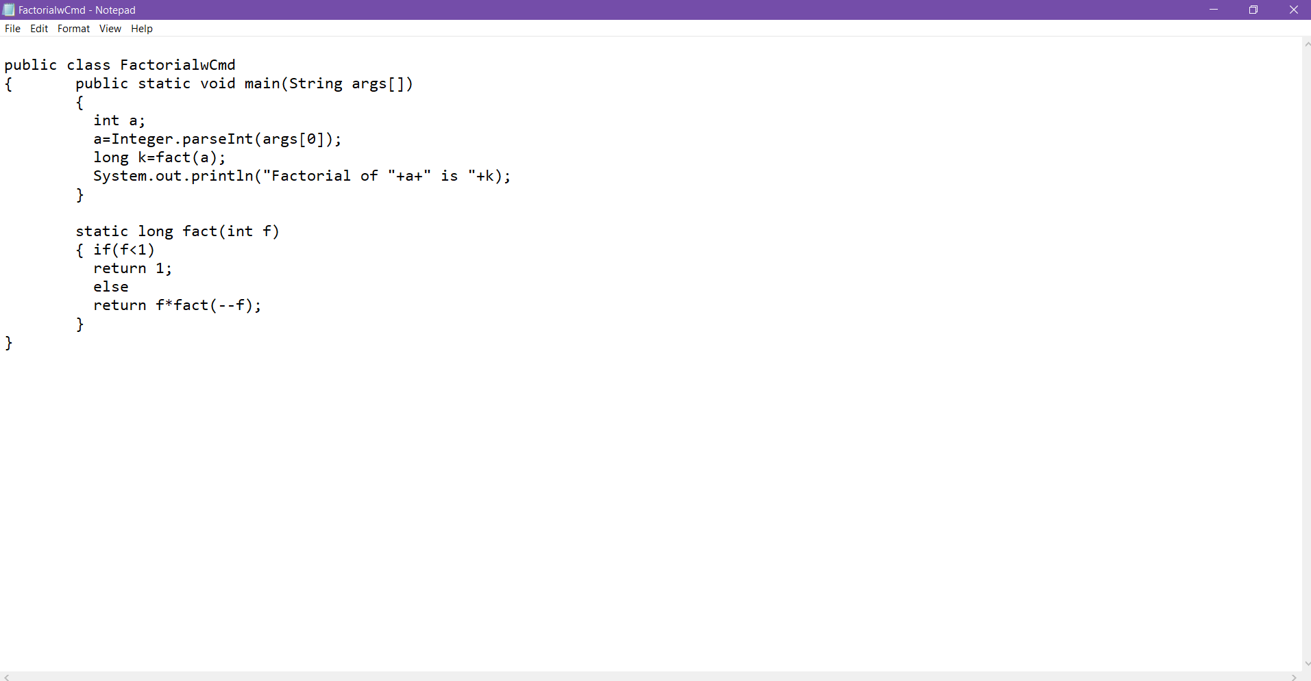

OUTPUT:

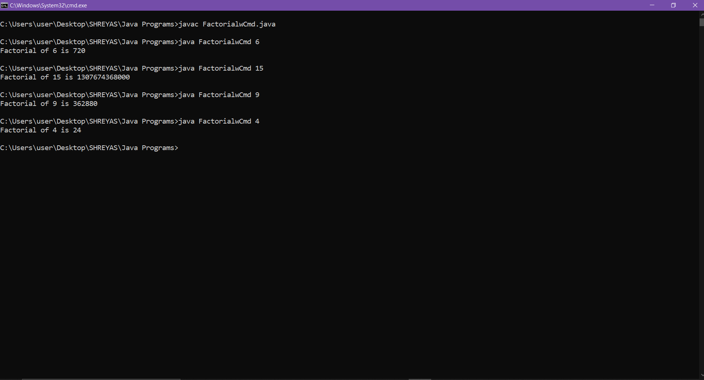

b) With Scanner Class

CODE:

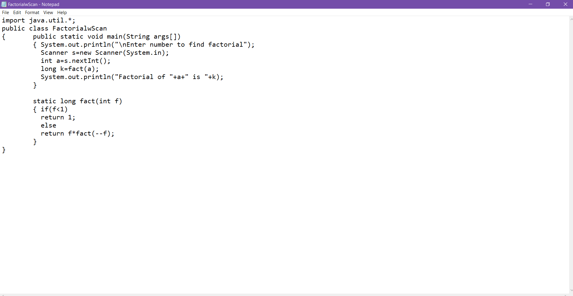

OUTPUT:

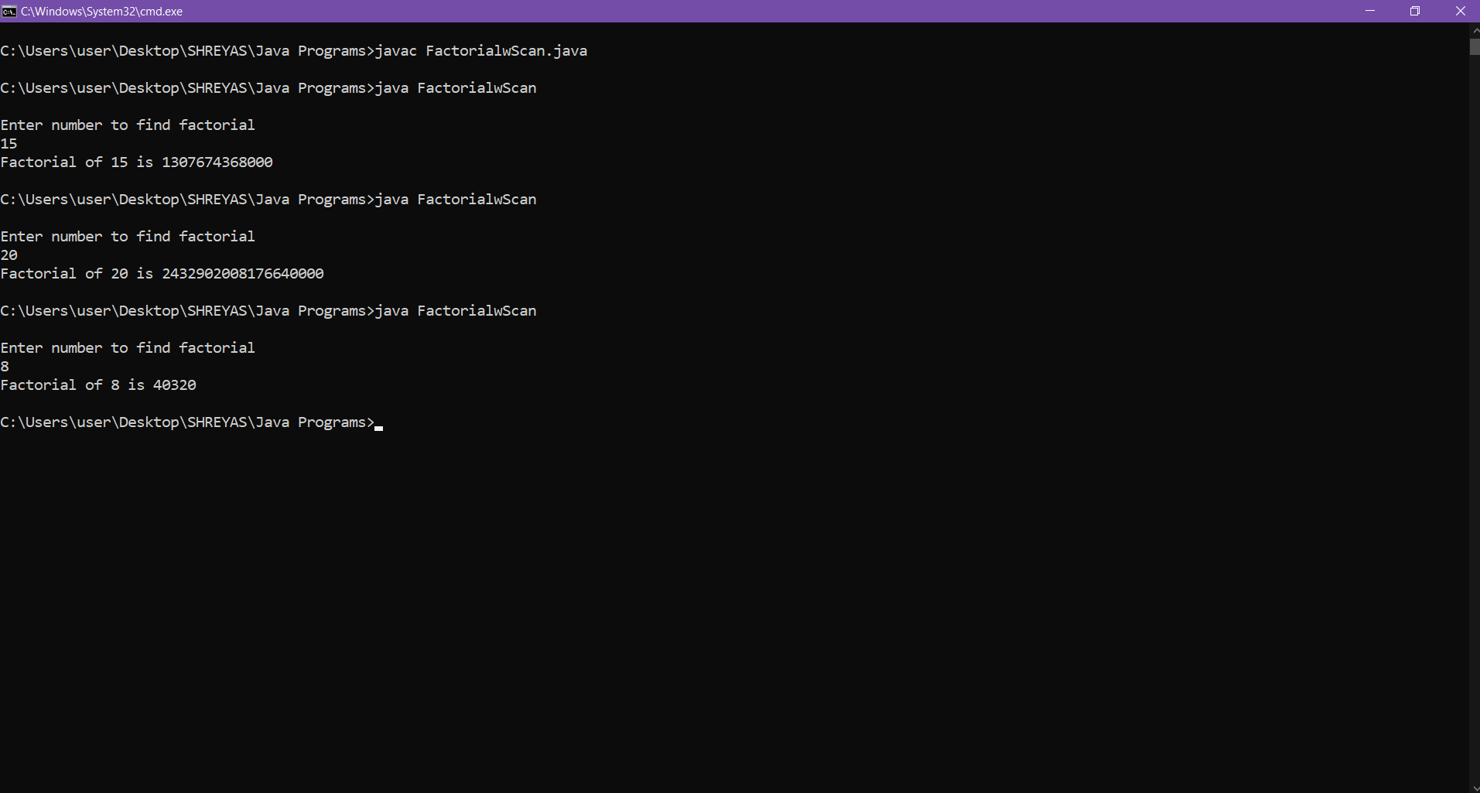

Q.3 Write a program to print fibonacci series upto n terms, n taken from user.

a)With CLA

CODE:

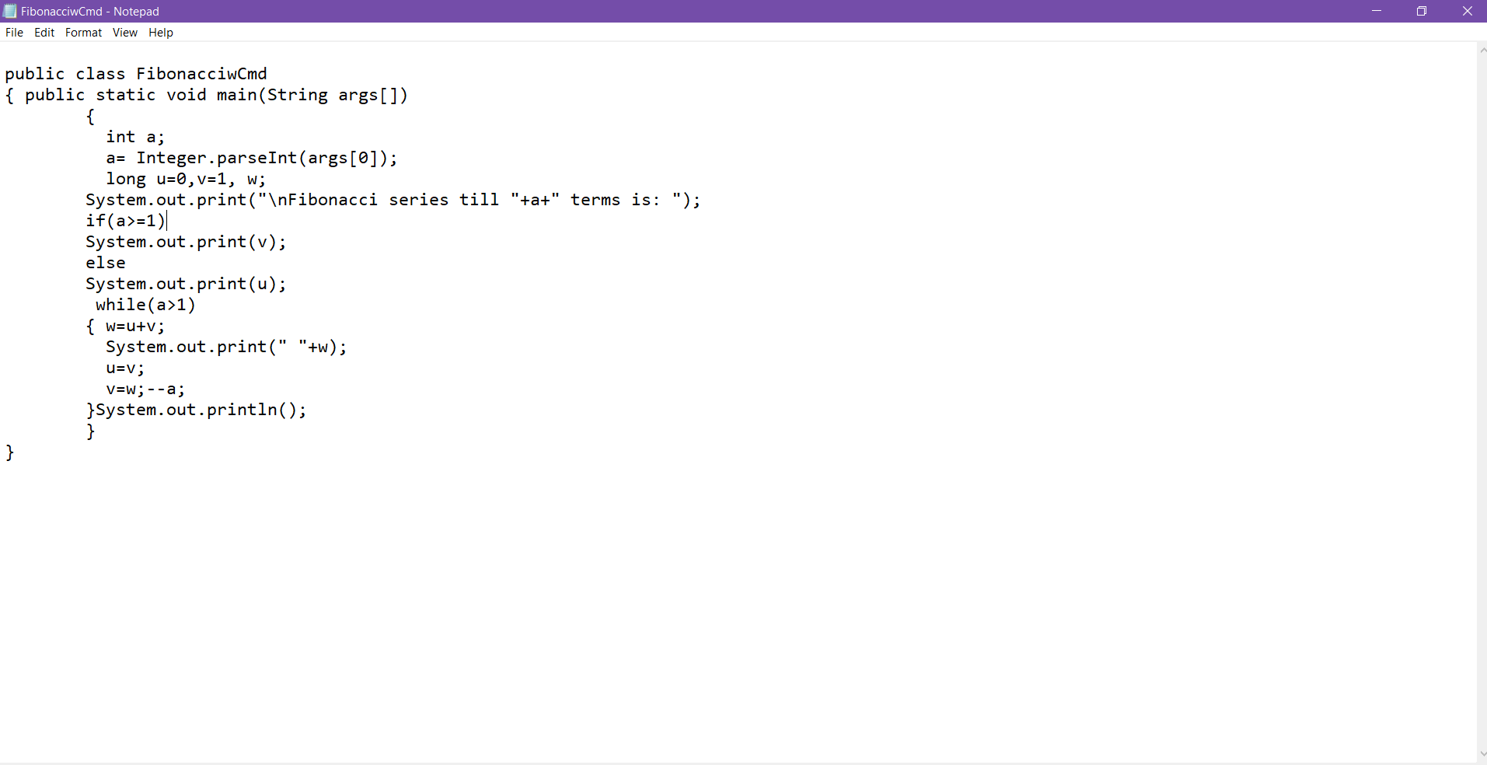

OUTPUT:

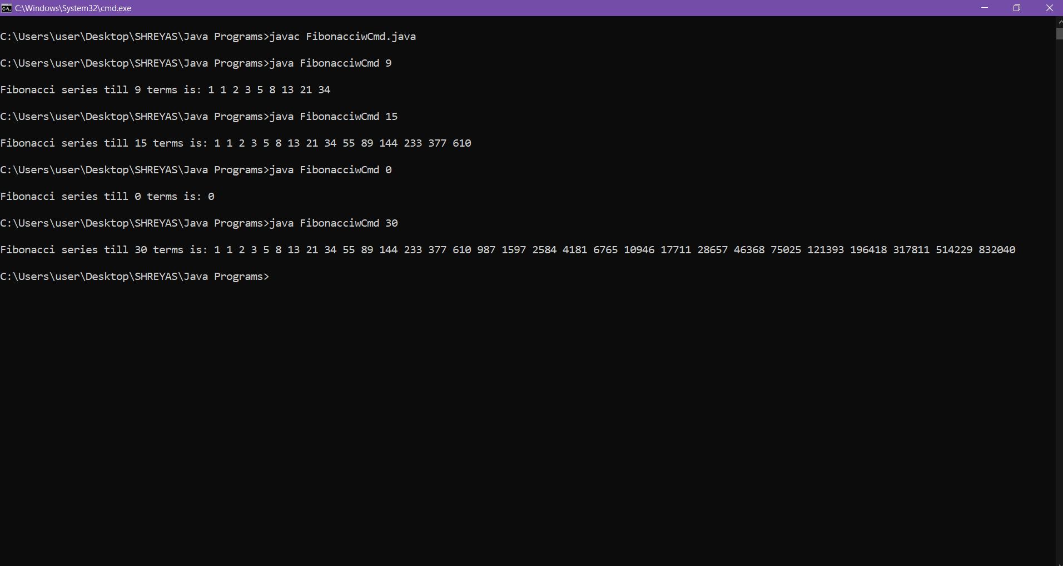

b) With Scanner Class

CODE: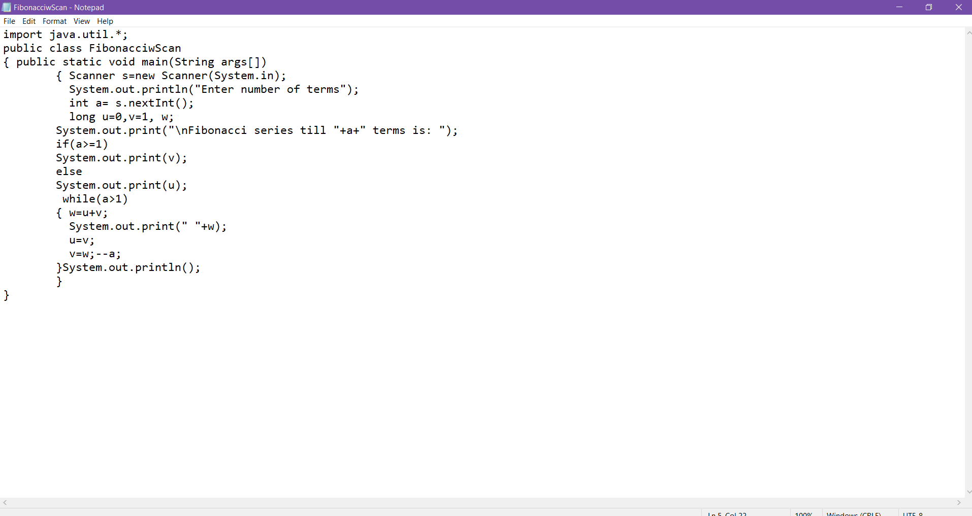

OUTPUT:

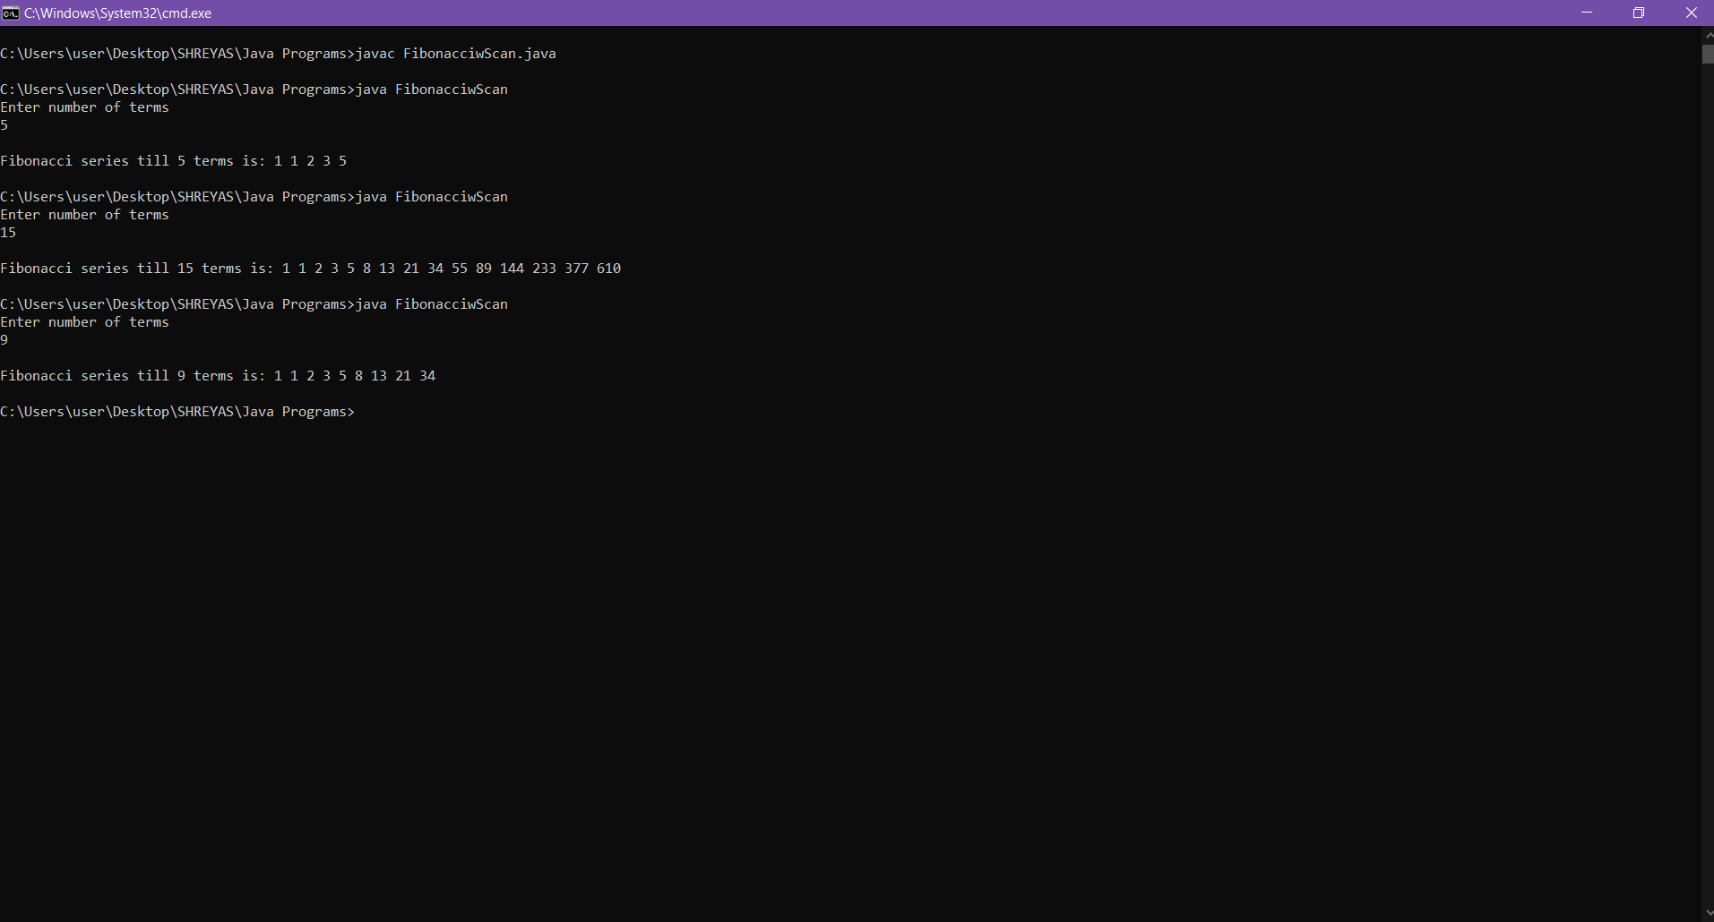

Q.4 Write a program to enter number of particpants from user take the names from user and print them.

a) With CLA

CODE:

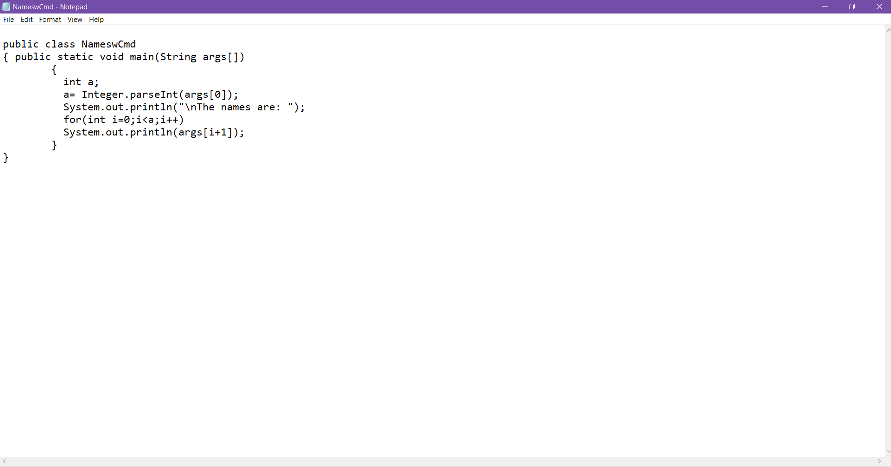

OUTPUT:

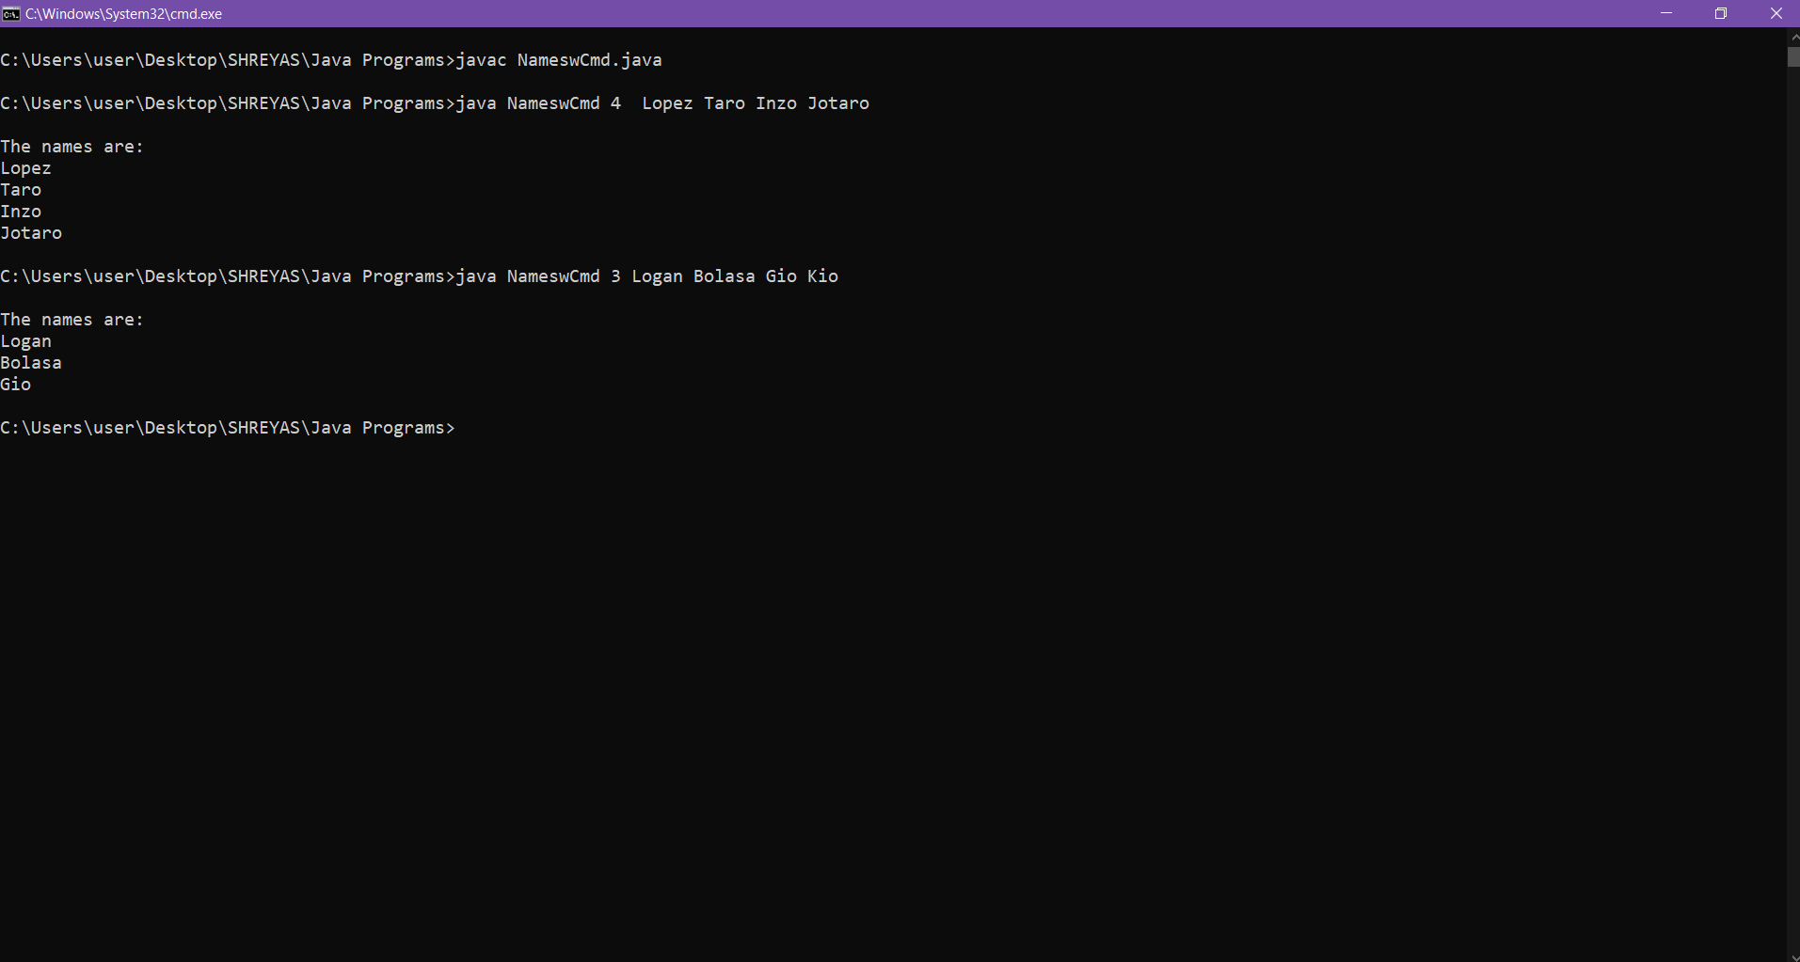

b) With Scanner Class

CODE:

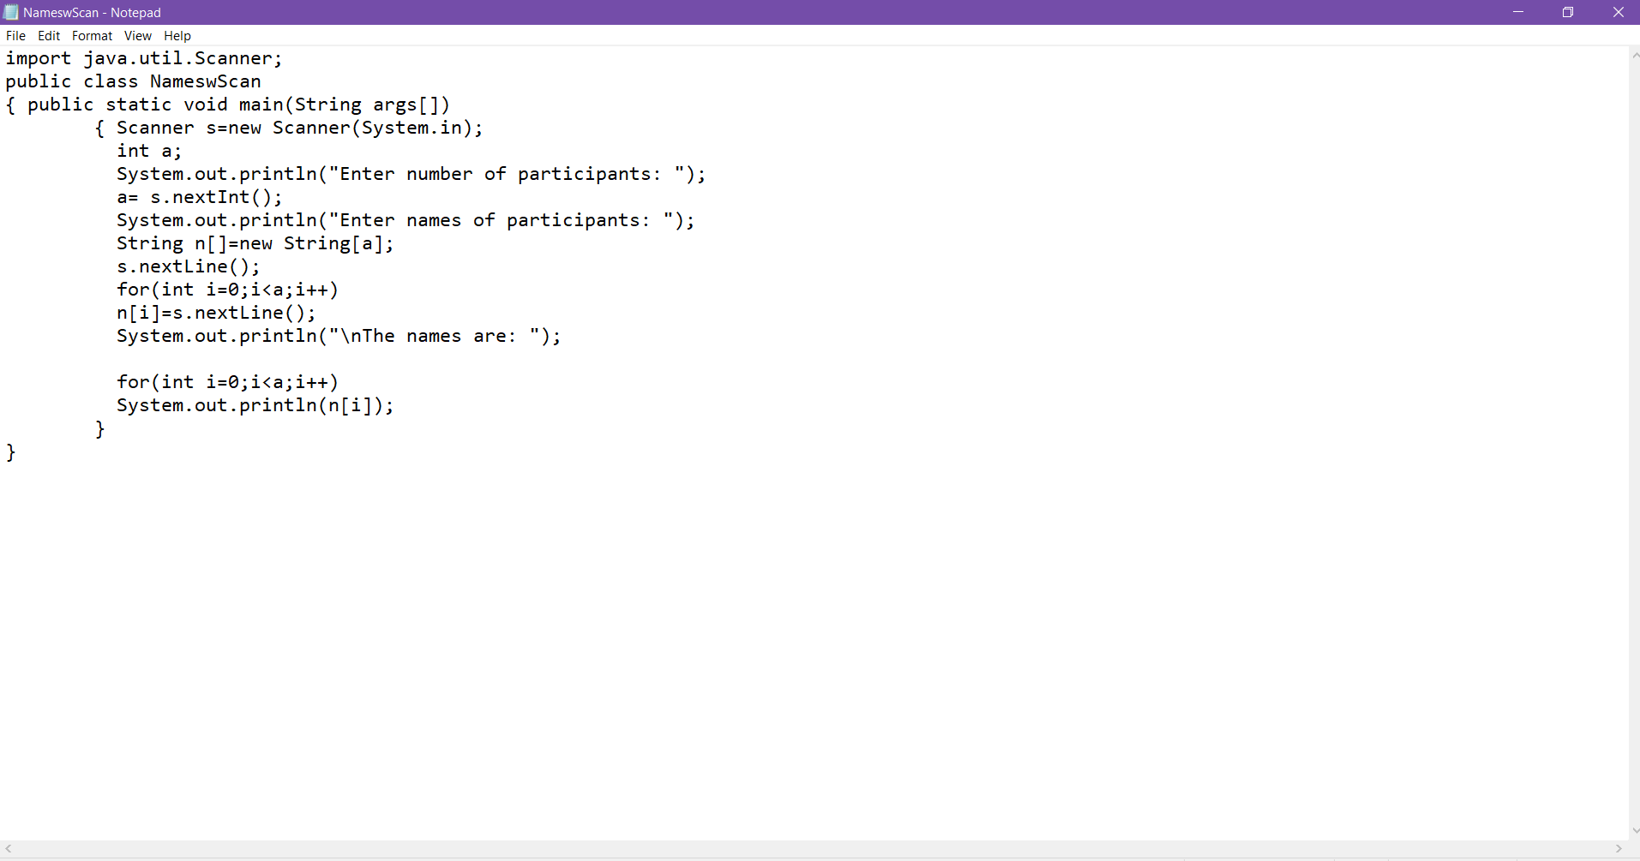

OUTPUT:  
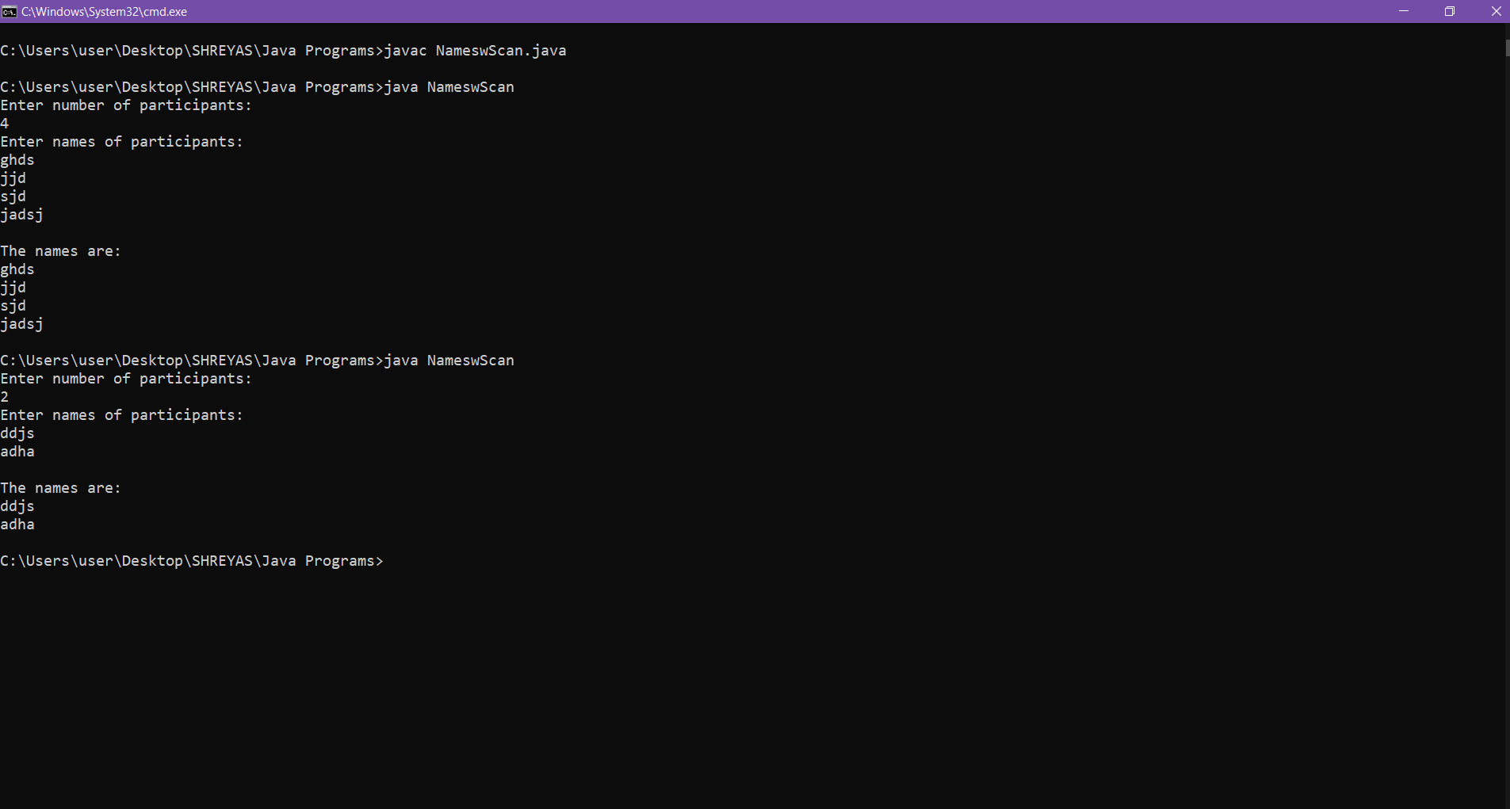

Q.5 Write a program to reverse the number entered by user.

a) With CLA

CODE:

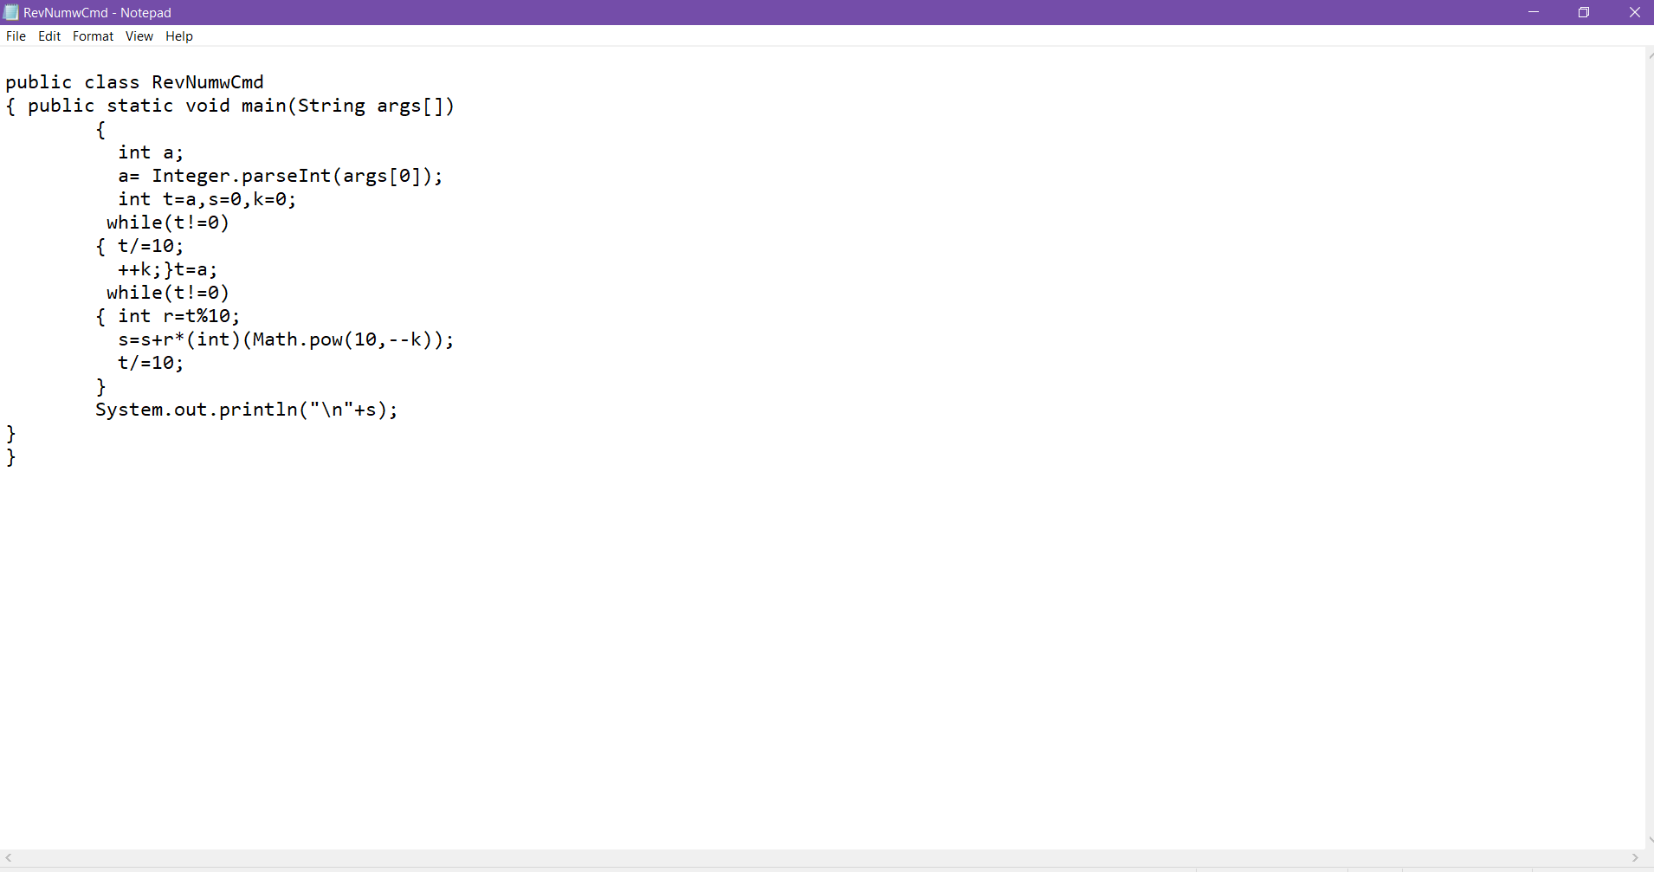

OUTPUT:

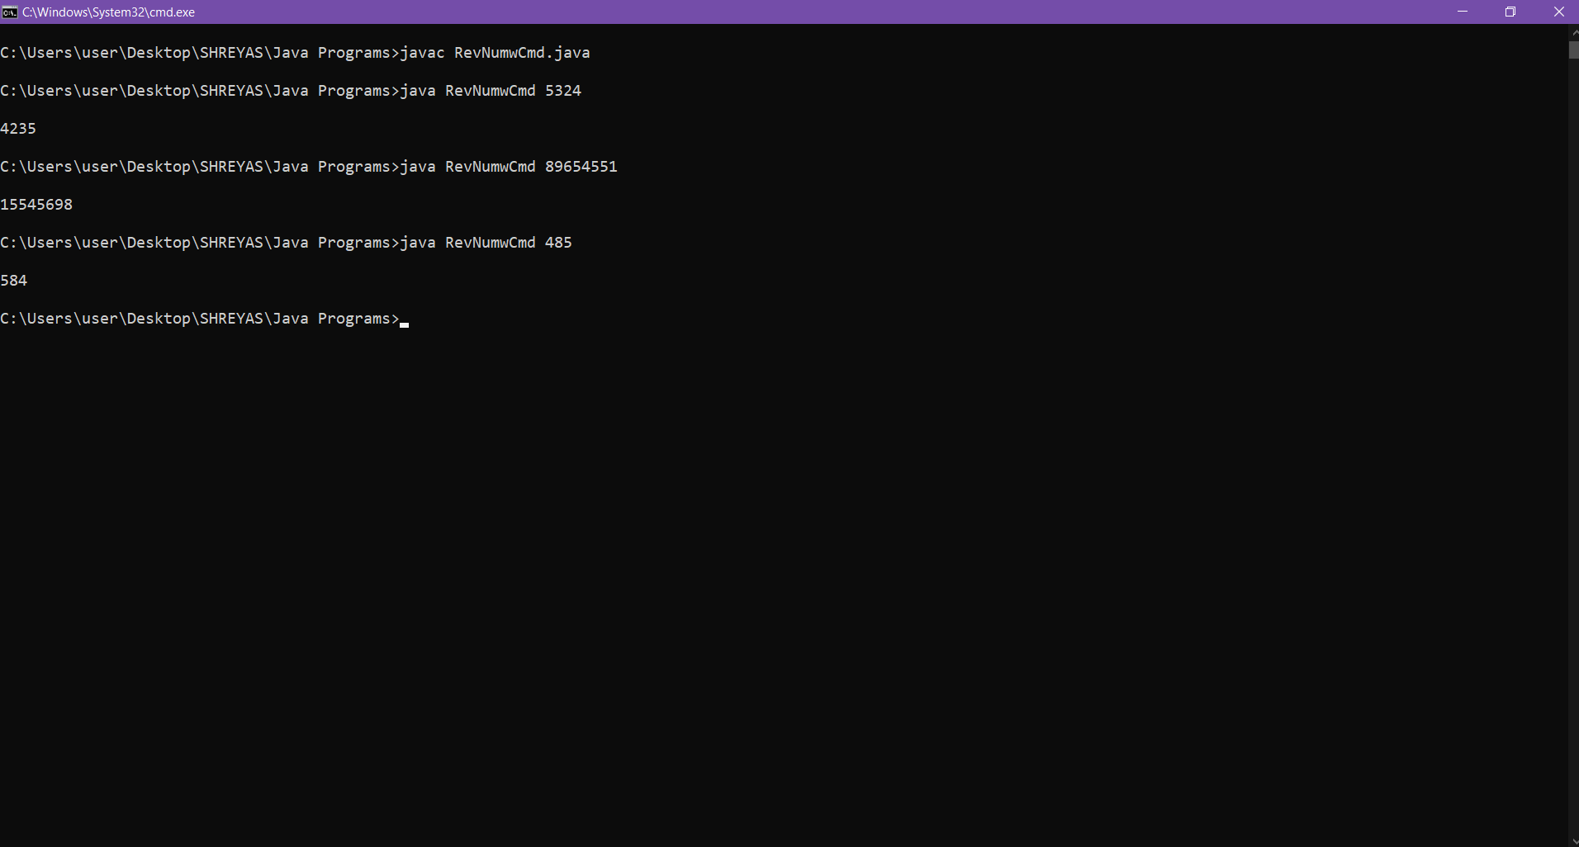

b) Scanner Class

CODE:

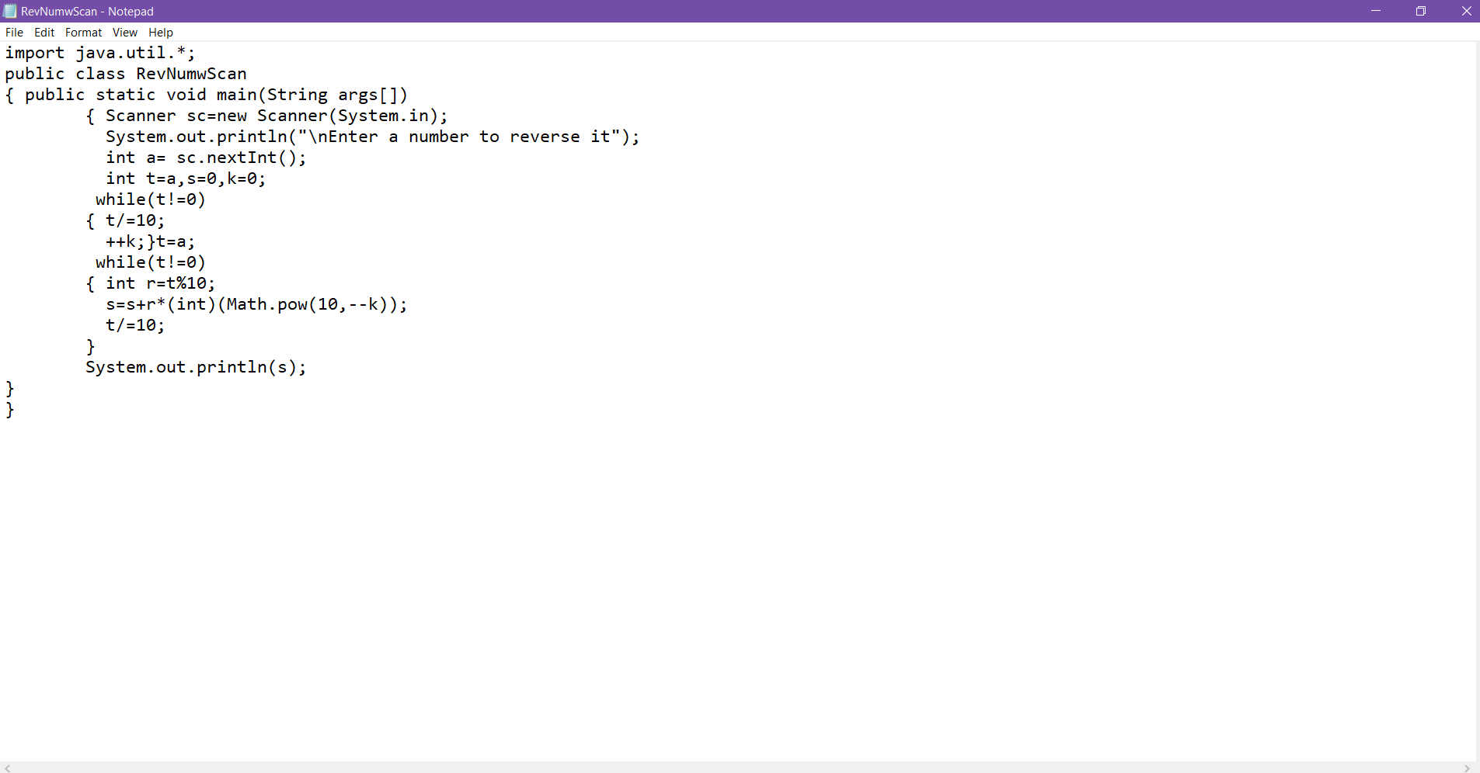

OUTPUT: